# Problem 4 – Island

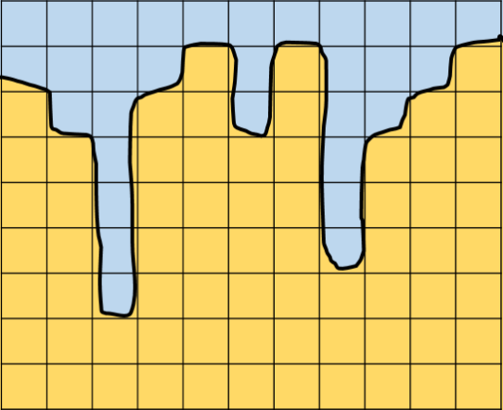You are almost over with the algorithms course. And you plan to retire and spend the rest of you life in a sweet hotel on the coast of some island. Nothing is ever so easy, is it?

You are given **a map of the island**. The yellow parts denote the coast and the blue parts denote the sea. The hotel you want to build has a **rectangular** shape. Each square has **area = 1**.

Find the **maximal area** on the coast that can fit your hotel.

#### Input

On the first input line you will be given a sequence of numbers,  
representing the area of each column (the coast).

#### Output

Print the **maximal area** your hotel can have.

#### Constraints

* The **number of columns** in the input sequence will be in the range [1…300 000].
* Columns will be integer numbers in the range [0…15 000].
* Time limit: **200 ms**. Allowed memory: **50 MB**.

#### Examples

|  |  |  |  |  |
| --- | --- | --- | --- | --- |
| **Input** | **Output** |  | **Input** | **Output** |
| 7 6 2 7 8 6 8 3 6 7 8 | 24 |  | 20 3 5 8 4 7 8 6 9 | 28 |